Mandatory Training Action Summary – User Guide

The Mandatory Training Action Summary is designed as a simpler alternative to the full Compliance Report, focusing on actions rather than detailed analysis.

The report gives users a clear and actionable view of the completion status against the list of the currently agreed all-staff university mandatory training courses.

- Anti Bribery & Corruption: Managing the risk
- Conflicts of Interest: Identifying interests and making declarations
- Equality and Diversity Briefing
- Harassment in Higher Education
- Health & Safety Basics eLearning
- Information Security and Data Protection

The report shows who has completed a course as well as those who have never taken the current version of the course, or who need to repeat and require reminders. It includes email addresses to allow email reminders to be sent by administrators. The report updates daily at 2 am.

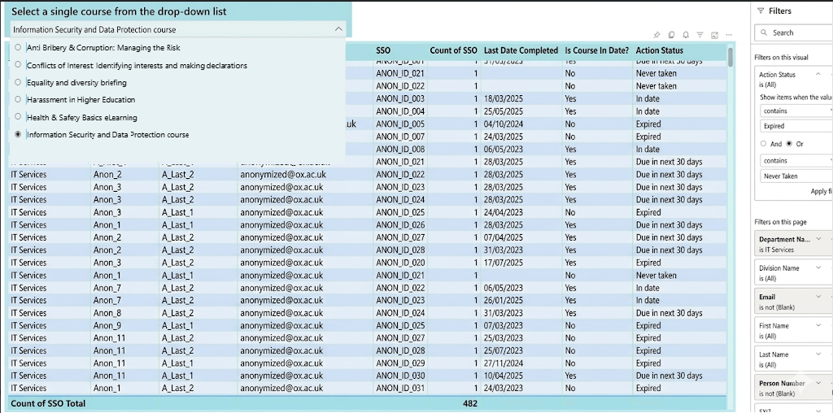

Key data featured in the report are:
- Individuals whose completion status is currently up to date
- Individuals whose completion status will expire within the next thirty days
- Individuals whose completion status has already expired
- Individuals who have not taken the current version of the course
This report is simpler than the full compliance report, with fewer columns. If you want more details about a person or to check any compliance courses not shown in the Mandatory Training Action Summary, use the full Compliance Report.
This page outlines how to use the Mandatory Training Action Summary, including:
- How to access the report
- Navigating and filtering data
- Exporting lists with email addresses to contact staff
- Admin guidance for multi-department access
- Steps for managing incorrect or missing data
This guide does not include:
- Details about PeopleXD, CUD, or HR systems
- Using or interpreting the Standard Compliance Report (separate guidance is available)
- Data transformation, pivot tables, or advanced Power BI techniques
- Running communications campaigns

How to Access the New Mandatory Training Action Summary
This report is part of the Compliance Report and appears as a separate page alongside the full Compliance Report.

Open Power BI Compliance Reports app. Help on this is in our Getting Started Guide.
From the left-hand navigation menu, open the Mandatory Training Action Summary report. It is located between Compliance Training General/Enhanced and Report Help & Guidance.
After the page loads:
• The first item is a course selection drop-down, located at the top left of the page
• Below this is a data table showing the report results
• On the right-hand side of the page is a panel containing filters

Navigating the Report

Course selection
At the top left of the main report page, there is a course selection drop-down.
Use the drop-down labelled “Select a single course from the drop-down list” to choose the course you want to check.
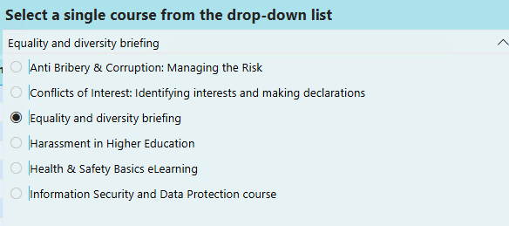
The list includes the University-wide mandatory courses that are currently agreed.
You must only select one course at a time as multiple selections are not available.

Main data table
The main data table is in the centre of the report page.
For each person, the table shows the following information, from left to right:
- Department
- First name
- Last name
- Email address
- Single Sign-On-, also known as SSO
- Date the course was last completed
- Is course in date? Shown as Yes or No
- Action status, which may be one of the following:
  - In date
  - Due in the next 30 days
  - Expired
  - Current version not done

Filters panel
The filters panel is located on the right-hand side of the page.
You can use the filters to narrow the data shown in the table. Filter options include:
- Department name
- Division name
- Email address
- First name
- Last name
- Person number
- SSO
- Staff - Employee status descriptions

Using filters
You can use filters to focus on specific groups of people in the list. For example, you can use filters to find learners who have not completed the current version of a course.

Some filters are applied by default to remove information that is not usually needed. These preset filters mean that:
- Email address is not blank
- Person number is not blank
- Staff - Employee status description does not include nonemployee, blank, or Z category

Filtering by action status
To filter the report by action status, follow these steps:
- Select the data table in the centre of the report page.
- In the filters panel on the right-hand side, locate the Action Status filter at the top of the panel.
- In the Action Status filter, ensure the drop-down menu is set to contains. This means the report will match any action status that includes the word you enter.
- In the text box below the contains option, type the term you want to filter by, for example type the word expired.
- Press Apply Filter
- The details in the data should change to reflect your filter. If the data does not change, check that you have selected the Apply filter button at the bottom right corner of the filter panel. When the filter is applied, it is shown as active and the filter name changes to indicate that it is applied.

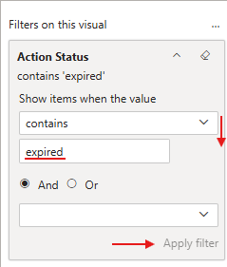

Example filter terms
You can use the following terms to display different groups:
- To show individuals whose completion status is currently up to date, type the words in date into the Action Status filter.
- To show individuals whose completion status will expire within the next 30 days, type the word due into the Action Status filter.
- To show individuals whose completion status has already expired, type the word expired into the Action Status filter.
- To show individuals who have not completed the current version of the course, type the words not in into the Action Status filter.

Using more than one filter term
You can filter on more than one action status at the same time.
For example:
- Add a filter using the contains option, then type the word expired into the filter text box
- Select the Or option to include more than one action status in the results
- Add another filter using the contains option, then type the words not in into the filter text box
This will show both groups in the same report.

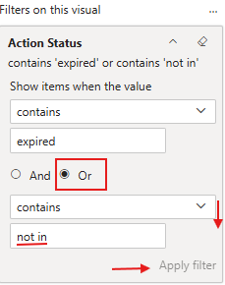

Clearing the action status filter
To remove the Action Status filter, select the Clear filter icon to the right of the Action Status heading. Once cleared, the Action Status will show is (All), indicating that no filter is applied.

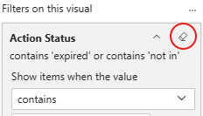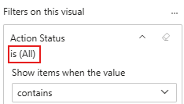

You can also check specific individuals by using the Filters on this page, below Action Status, such as the First Name, Last Name, SSO, or Person ID filters.

Exporting data
You can export the data from the report to create a clean list for further work.
To export the data, follow these steps:
- Locate the More options button for the data table (three dots) in the top right corner of the table. This button opens additional actions for the table.

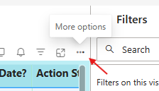

- Select Export data. This is the fifth option in the menu.
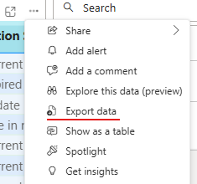
- Choose Default data with current layout.
- Save the file. The exported file will normally be saved to your default Downloads location, depending on your browser and University device settings. If you cannot find the file, check your Downloads folder first.

Guidance for multi-department administrators
If you have access to more than one department, the report behaves in the following way:
- Each person appears once for each department they are affiliated with
- Only one email address is shown for each person, to help avoid sending duplicate emails

When data looks incorrect
Sometimes the data may not look as you expect. Common reasons include:
- Missing person numbers or SSOs, where the Central User Database (CUD) and PeopleXD- records do not match
- Blank email addresses for virtual card holders
- People with more than one affiliation may not have a person number for every affiliation
- College staff often do not have a central University person number
Please note that data in PeopleXD is overwritten by the Central User Database (CUD) every two weeks, which may affect how recently changes are reflected.

What to do if someone is missing from the report
If you think a person should appear in the report but does not, try the following steps:
- Remove the filters for email address and person number. Re-apply the filters one at a time.
- Check whether the person then appears in the table.

Getting further help
- If the person still does not appear, contact cosy-support@it.ox.ac.uk for assistance.
- When you contact support, include:
- The person’s SSO or email address
- Their department or affiliation
- A brief explanation of why you believe they should appear in the report.

